**THE COPYCLOSET™ PRESENTS …**

**#FIXITJESUS   
WRITING WORKSHOP**

Disclaimer: The information contained herein is general in nature and for informative purposes only. It is based on the author’s personal experience. The author assumes no responsibility whatsoever, under any circumstances, for any actions taken as a result of the information contained herein.

**Copyright © 2016. BAAB Writing and Marketing Services LLC. All Rights Reserved.** No part of this document may be reproduced or shared without express, written consent from the author.

Contents

#FIXITJESUS WRITING WORKSHOP 4

ROLONDA 5

RAMONICA 6

PRISCILLA 7

CAMILLE 8

LEKEISHA 9

MEET YOUR MILLION-DOLLAR WORD STYLIST 10

# #FIXITJESUS WRITING WORKSHOP

All reviews were conducted LIVE during the workshop. If you missed the workshop, you can watch the video to access your review.

# ROLONDA

**EDITED CONTENT (NOTE THIS IS NOT A FULL/FINAL REWRITE)**

***You may also consider a first-person bio for LinkedIn***

Rolonda Hernandez is a financial business strategist, revenue booster and lover of all things strategic. She is the one entrepreneurs call for assistance with streamlining operational processes, plugging revenue holes and improving standard operating procedures.

A former Director of Finance & Accounting, Director of Finance and Administration and CFO for nonprofit organizations and pharmaceutical companies, Rolonda has more than 10 years of executive-level experience. She is also a Yardi software specialist in property management industries where she tracks conversions and upgrades.

Presently, Rolonda is leading a restructuring project to improve client acquisition and engagement. In this lead role, she is employing her comprehensive knowledge of real estate, financial, and IT management best practices to make these changes a success.

With extensive experience in minimizing inefficient processes and maximizing revenue, Rolonda is the one to call for all your business strategy needs.

Tired of wasting time, resources and profits on inefficient business processes? Let her create a plan to fill your revenue gaps and put your business on track to sustainable growth.

# RAMONICA

**EDITED CONTENT (NOTE THIS IS NOT A FULL/FINAL REWRITE)**

***You may also consider a first-person bio for LinkedIn***

I’m Ramonica Gamble, the Queen of Customer Service. I teach small business owners how to attract customers and deliver remarkable experiences that keep them coming back for more.

Now, my job is to make sure YOU never join that club of entrepreneurs who are losing 64 BILLION DOLLARS in revenue every single year simply because they have no idea how to treat a customer right!

# PRISCILLA

**CONTENT REVIEW**

***Home page***

I suggest you work to revise the tagline:

***For the risk takes and out of box thinkers who want to change the world.***

I can put this on any website and it will mean the same thing no matter the service provided. That means this is too vague and doesn’t give enough detail to let browsers know they’re in the right place.

For some tips on focusing on the specific benefits for your buyers, check out Copywriting 101, Writing to Sell (In the Vivacious Vids + Webinars section). Also, I want you to create a table where you list the features of what you do one side and match a benefit to every single benefit.

The goal here is to get you thinking in terms of the desired outcome your buyers want and how you deliver that versus general statements like “change the world.”

# CAMILLE

**CONTENT REVIEW**

***Landing Page***

I want you to use more descriptive words. Lose weight is overused and cold. Make your people visualize what this looks like …

The Faith Walk

Shed the Pounds

Faith Inspired Fitness

Be a witness for fitness

I suggest include some type of intro text before your bullets:

Something like:

*You pray every single day and now it’s time to be a witness for fitness.*

Also, you may also consider adding a short bio about yourself. Your story is so incredible, people can relate to it so share it.

# LEKEISHA

**CONTENT REVIEW**

***Home page***

You mentioned a freebie on your questionnaire, but I couldn’t find it on your site and you didn’t show up for the workshop for me to inquire. Therefore, I reviewed your home page:

I see you’ve written a lot of your copy in 3rd person. This should be an actual conversation. Write in first person so your visitors can connect with you instead of feeling like their talking to a “business.” First person humanizes your writing and makes you come across more relatable. As an unstuck coach, you need folks to trust you and first they need to be able to relate to you.

# MEET YOUR MILLION-DOLLAR WORD STYLIST

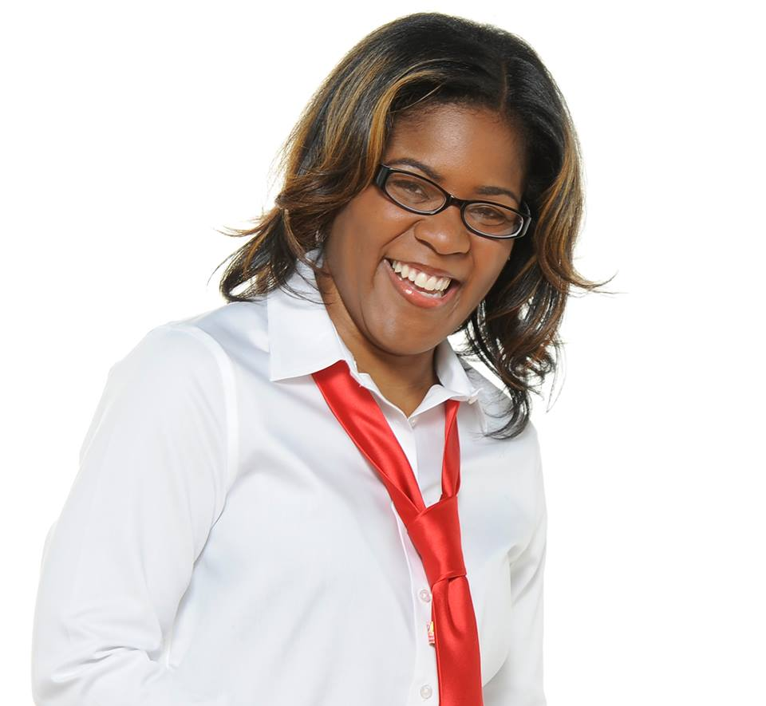Apryl Beverly, the “Million-Dollar Word Stylist” and founder of **BAAB Writing and Marketing Services**, crafts copy that has generated millions in revenue for solo entrepreneurs and some of the top brands in the United States.

Known for her educated, “tell-it-like-it-is” writing style, she recently hit the Amazon Top 5 Best Seller’s List in 3 categories just 24 hours after releasing her first book, “Shots Fired! How to Write Copy that Pierces Hearts (And Opens Wallets).” Her recent book, *F.A.S.T. Money!* shot to the No. 1 spot on the Amazon Best Seller’s List 24 hours BEFORE the book’s official release!

In addition to being a sentence slinger, Apryl is a mom to the most amazing kid in the universe and is married to the masterful “money man.”

Learn more about Apryl at [baab.biz](http://www.baab.biz) and download her first bestselling book at [shotsfired.co](http://WWW.SHOTSFIRED.CO). You can grab your copy of *F.A.S.T. Money!* [here](http://www.fastmoneybook.co).